WS/22

Aircraft Desing – Things to be Known

Lift

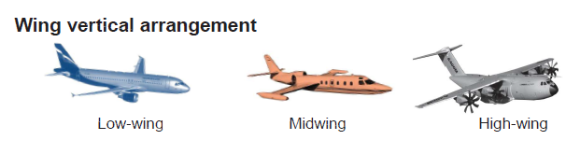
5 Main Parameter

Airfoil pressure distribution can be taileroed by …..

3D effects at finite span…..

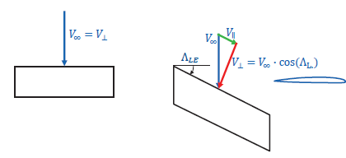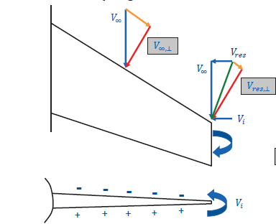

Camber and Incıdence: Lift Curve Shift

